The UI code is based off an FSM as diagrammed below.

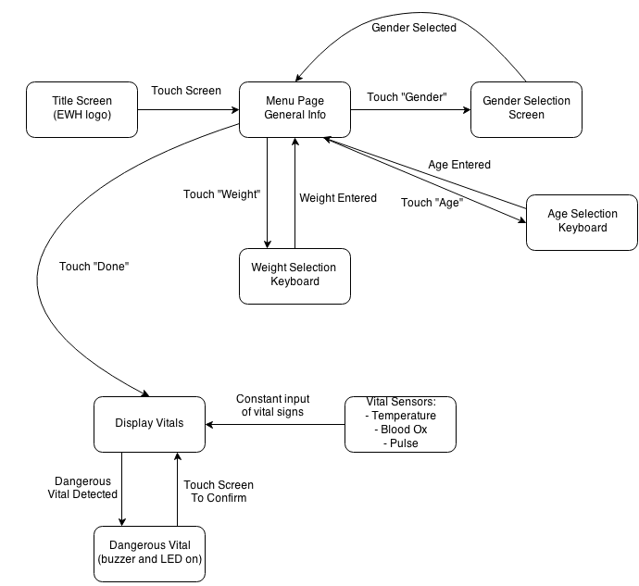

**Details for each state:**

* Title Screen: Displays “Cornell EWH”, and transitions to input menu when screen is touched.

**(Insert screenshot here)**

* Menu Page: Displays four rectangular boxes, vertically. From top to bottom, the boxes are for age selection, gender selection, weight selection, and a Done button. The menu page transitions to each of the next state depending on a touch of each of these boxes.
* Weight Selection/Age Selection: Transitions to a keyboard state, which is based off the Henning Karlsen ButtonTest UTouch example code, with some modifications. <http://www.henningkarlsen.com/electronics/library.php?id=55> is the link to the UTouch library. The modifications made were the colors of the keypad and the functionality of the buttons. The “Enter” button does not start the next line, but rather, is the done signal to the keypad, and starts a calculation of the number inputted. The number is then sent back to the main FSM for the respective selection (Weight or Age).

**(Insert screenshot)**

* Gender Selection: The gender selection is another 2 button selection system, one representing Male and the other representing Female. A button press returns the selection to the earlier screen.

**(Insert Screenshot)**

* Done: After all of the information is entered, pressing the “Done” button confirms that no more modifications will be made and transitions the screen to the displaying of the vitals.
* Display Vitals: State that does two things: displays the vitals and alerts for dangerous changes in vitals. This is done with a 4 way split in the screen, with the bottom left for temperature, the top right for pulse, and the bottom right for oxygen levels.

**(Insert screenshot)**

* Vital Sensors: get input from the sensors to display the vitals.
  + Temperature:
  + Pulse: Moving average filter takes up too much RAM, and breaks the UI code. This needs
* Dangerous Vitals: upon dangerous changes in the vitals, send alert through buzzer and LED that a dangerous change has occurred. A touch of the screen confirms acknowledgement.